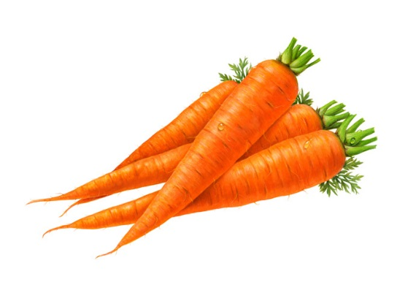

Place **Unopened** items you don’t want onto the   
Sharing Table.

**Throw away** other

opened leftovers.

**Take** either your fruit or vegetable with you!

***Can’t finish your meal?***