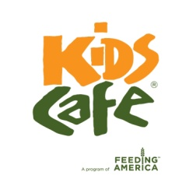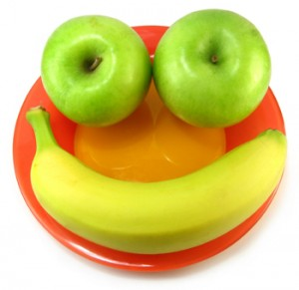

*St. Mary’s Food Bank is an equal opportunity provider and employer*

**any item left out of cold storage is no longer safe for consumption**

The proper use of meals follows these steps:

1. Serve meals to kids in the program first (all meals served to kids in the program must be consumed on site)
2. Serve all meal components together including MILK; do not allow kids to choose individual items
3. Designate a Sharing Table and encourage kids to share and place unwanted,

un-opened items in the designated area. Encourage Kids to take fruit or vegetable home instead of throwing in the trash.

1. Return all perishable leftovers to cold storage immediately after meal service ends. Perishable items are not safe to consume after 15 minutes out of cold storage.
2. The Kids Cafe® driver will pick up any leftovers and return them to the Food Bank for use to other needy families

**Meal Service and Leftover Reminder**